**Fop Lab Home Task 5**

**Name:** Hafiz Mufassir Amjad

**CMS ID:** 456049

**Section:** B

**TASK 1**

#include <iostream>

using namespace std;

int main()

{

int num1, num2, bigger, HCF;

double LCM;

cout<<"Enter number 1: ";

cin>>num1;

cout<<"Enter number 2: ";

cin>>num2;

if (num1>num2)

bigger=num1;

else

bigger=num2;

for (int i = 1; i<=bigger; i++) {

if (num1%i==0 && num2%i==0)

HCF = i;

}

LCM = ((double)num1*(double)num2)/(double)HCF;

cout<<"LCM of "<<num1<<" and "<<num2<<" is "<<LCM;

}

**Output**

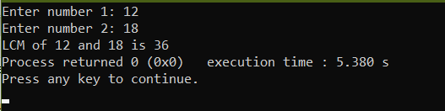

**Explanation**

This code takes two integers from the user and calculate the HCF of both numbers by using a for loop. Then it calculates LCM by dividing the product of both numbers by their HCF.

**TASK 2**

#include <iostream>

using namespace std;

int main()

{

int a, n, d, sum;

cout<<"Enter first term: ";

cin>>a;

cout<<"Enter No. of terms: ";

cin>>n;

cout<<"Enter the difference: ";

cin>>d;

sum = (n/2)*(2*a+((n-1)*d));

cout<<"Sum of AP series is "<<sum;

}

**Output**

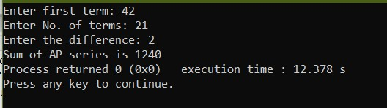

**Explanation**

This code takes First term of the AP, difference and No. of terms in AP as input from the user and then calculates the sum of AP series using the formula $S=\frac{n}{2}[2a+\left(n-1\right)d]$

**TASK 3**

#include <iostream>

#include <string>

using namespace std;

int main()

{

int spaces;

for (int i = 1; i<=9; i+=2) {

spaces = 9-i;

for (int j = 1; j <= spaces/2; j++) {

cout<<" ";

}

for (int j = 1; j <= i; j++) {

cout<<"*";

}

cout<<endl;

}

for (int i = 7; i>=1; i-=2) {

spaces = 9-i;

for (int j = 1; j <= spaces/2; j++) {

cout<<" ";

}

for (int j = 1; j <= i; j++) {

cout<<"*";

}

cout<<endl;

}

}

**Output**

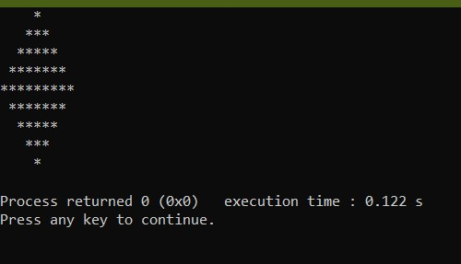

**Explanation**

This code uses nested for loops for print a diamond shape. The outer loop calculates how much stars each line will print. Inner loops use that value to print spaces and stars accordingly.

**TASK 4**

#include <iostream>

#include <string>

using namespace std;

int main()

{

int remainder, quotient, num;

cout<<"Enter the decimal number: ";

cin>>num;

string bin;

quotient = num;

while(quotient != 0) {

remainder = quotient % 2;

quotient /= 2;

if (remainder == 1) {

bin = '1' + bin;

} else {

bin = '0' + bin;

}

}

cout<<bin;

}

**Output**

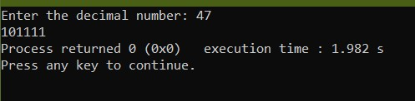

**Explanation**

This code takes a decimal number as input and converts it into a binary number. It uses a while loop where it divides the number by quotient and then it divides quotient by itself again and again till the quotient becomes 0. In all these steps, it calculates the remainder and prepend it in a string. The string is finally the decimal number.